41.23: Using Eq. (41.27) for the ionization energy: 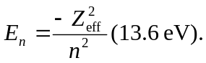 The 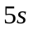 electron sees 